**Question 1**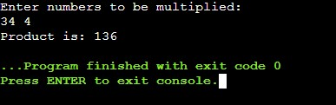

#include <iostream>

using namespace std;

int multiply(int a, int b) {

return a*b;

}

int main() {

int m,n;

cout<<"Enter numbers to be multiplied: "<<endl;

cin>>m>>n;

cout<<"Product is: "<<multiply(m, n);

return 0;

}

**Question 2**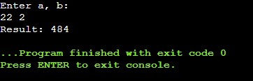

#include <iostream>

using namespace std;

int power(int m, int n){

int num=1;

for(int i=1; i<=n; i++)

num *= m;

return num;

}

int main(){

int a, b;

cout<<"Enter a, b: "<<endl;

cin>>a>>b;

cout<<"Result: "<<power(a, b);

return 0;

}

**Question 3**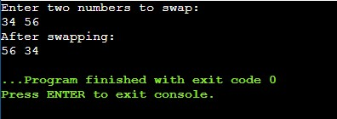

#include <iostream>

using namespace std;

void swap_by_value(int m, int n){

int temp;

temp=m;

m=n;

n=temp;

cout<<m<<" "<<n;

}

void swap_by_reference(int *m, int *n){

int temp;

temp=*m;

*m=*n;

*n=temp;

cout<<*m<<" "<<*n;

}

int main()

{

int a, b;

cout<<"Enter two numbers to swap: "<<endl;

cin>>a>>b;

cout<<"After swapping: "<<endl;

// swap_by_value(a, b);

swap_by_reference(&a, &b);

return 0;

}

**Question 4**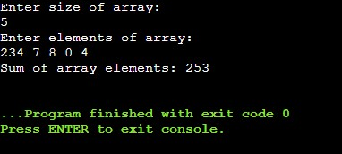

#include <iostream>

using namespace std;

int main(){

int n, *ptr, sum=0;

cout<<"Enter size of array: "<<endl;

cin>>n;

int arr[n];

cout<<"Enter elements of array: "<<endl;

for(int i=0; i<n; i++)

cin>>arr[i];

ptr = arr;

for(int i=0; i<n; i++){

sum += *ptr;

ptr++;

}

cout<<"Sum of array elements: "<<sum<<endl;

return 0;

}

**Question 5**

#include<iostream>

using namespace std;

#include<cstring>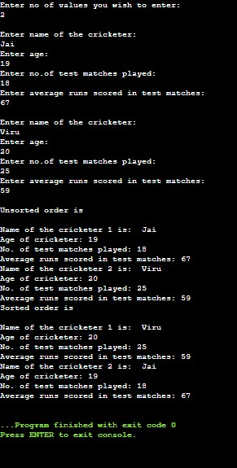

struct cricket{

char name[20];

int age;

int test;

int avg_runs;

};

int main(){

struct cricket data[20];

int n;

cout<<"Enter no of values you wish to enter: "<<endl;

cin>>n;

cout<<endl;

for(int i=0;i<n;i++){

cout<<"Enter name of the cricketer: "<<endl;

cin>>data[i].name;

cout<<"Enter age: "<<endl;

cin>>data[i].age;

cout<<"Enter no.of test matches played: "<<endl;

cin>>data[i].test;

cout<<"Enter average runs scored in test matches: "<<endl;

cin>>data[i].avg_runs;

cout<<endl;

}

cout<<"Unsorted order is "<<endl<<endl;

for(int i=0;i<n;i++){

cout<<"Name of the cricketer "<<(i+1)<<" is: "<< data[i].name<<endl;

cout<<"Age of cricketer: "<< data[i].age<<endl;

cout<<"No. of test matches played: "<< data[i].test<<endl;

cout<<"Average runs scored in test matches: "<< data[i].avg_runs<<endl;

}

struct cricket s1;

for(int i=0;i<n-1;i++){

for(int j=i+1;j<n;j++){

if(data[j].avg_runs<data[i].avg_runs){

s1=data[i];

data[i]=data[j];

data[j]=s1;

}

}

}

cout<<"Sorted order is "<<endl<<endl;

for(int i=0;i<n;i++){

cout<<"Name of the cricketer "<<(i+1)<<" is: "<< data[i].name<<endl;

cout<<"Age of cricketer: "<< data[i].age<<endl;

cout<<"No. of test matches played: "<< data[i].test<<endl;

cout<<"Average runs scored in test matches: "<< data[i].avg_runs<<endl;

}

}

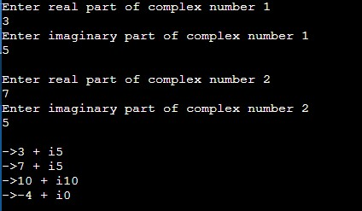

**Question 6**

#include<iostream>

using namespace std;

struct complex {

float real;

float imag;

};

complex add(complex n1, complex n2) {

complex temp;

temp.real = n1.real + n2.real;

temp.imag = n1.imag + n2.imag;

return (temp);

}

complex sub(complex n1, complex n2) {

complex temp;

temp.real = n1.real - n2.real;

temp.imag = n1.imag - n2.imag;

return (temp);

}

void display(complex n1){

cout<<"->"<<n1.real<<" "<<"+"<<" "<<"i"<<n1.imag<<endl;

}

int main(){

struct complex s1,s2,s3,s4;

cout<<"Enter real part of complex number 1"<<endl;

cin>>s1.real;

cout<<"Enter imaginary part of complex number 1"<<endl;

cin>>s1.imag;

cout<<endl;

cout<<"Enter real part of complex number 2"<<endl;

cin>>s2.real;

cout<<"Enter imaginary part of complex number 2"<<endl;

cin>>s2.imag;

s3=add(s1,s2);

s4=sub(s1,s2);

cout<<endl;

display(s1);

display(s2);

display(s3);

display(s4);

}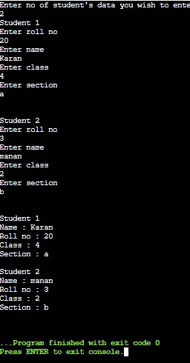

**Question 7**

#include <iostream>

#include <cstring>

using namespace std;

struct student

{

string name;

int roll_no;

int classes;

char section;

};

int main(){

struct student *x;

int n;

cout<<"Enter no of student's data you wish to enter"<<endl;

cin>>n;

x=new student[n];

for(int i=0; i<n; i++){

cout << "Student " << i + 1 << endl;

cout << "Enter roll no" << endl;

cin >> x[i].roll_no;

cout << "Enter name" << endl;

cin >> x[i].name;

cout << "Enter class" << endl;

cin >> x[i].classes;

cout << "Enter section" << endl;

cin >> x[i].section;

cout<<endl<<endl;

}

for(int i=0; i<n; i++){

cout << "Student " << i + 1 << endl;

cout << "Name : " << x[i].name << endl;

cout << "Roll no : " << x[i].roll_no << endl;

cout << "Class : " << x[i].classes << endl;

cout << "Section : " << x[i].section << endl;

cout<<endl;

}

delete [] x;

return 0;

}

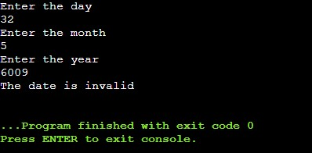

**Question 8**

#include<iostream>

using namespace std;

struct date{

int day;

int month;

int year;

};

void input()

{

date a;

cout<<"Enter the day"<<endl;

cin>>a.day;

cout<<"Enter the month"<<endl;

cin>>a.month;

cout<<"Enter the year"<<endl;

cin>>a.year;

}

void check()

{

date a;

if((a.month)<1||(a.month>12)||(a.day<1)||(a.day>31)){

cout<<"The date is invalid"<<endl;

return;}

if(a.month==2){

if(((a.year % 4 == 0)&&(a.year % 100 != 0))||(a.year % 400 == 0)&&(a.day<=29))

cout<<"The date is valid"<<endl;

else if(a.day<=28)

cout<<"The date is valid"<<endl;

else

cout<<"The date is invalid"<<endl;

return ;

}

if ((a.month == 4 || a.month == 6 ||a.month == 9 || a.month == 11)&&(a.day<=30))

cout<<"The date is valid"<<endl;

else if ((a.month == 1 || a.month == 3 ||a.month == 5 || a.month == 7||a.month == 8||a.month == 10||a.month == 12)&&(a.day<=31))

cout<<"The date is valid"<<endl;

else

cout<<"The date is invalid"<<endl;

}

int main()

{

input();

check();

}